1.flight count



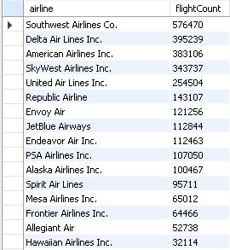

1.5.Problematic Flight Counts

select airline,

count(

case

when cancelled = 1 THEN 1

when dep_delay > 0 THEN 1

when arr_delay > 0 THEN 1

when DELAY_DUE_CARRIER > 0 THEN 1

WHEN DELAY_DUE_WEATHER > 0 THEN 1

WHEN DELAY_DUE_NAS > 0 THEN 1

WHEN DELAY_DUE_SECURITY > 0 THEN 1

WHEN DELAY_DUE_LATE_AIRCRAFT> 0 THEN 1

else 0

end ) as Problematic_Flight_Count

from flightdata

where airline = "Southwest Airlines Co.";



2.flight percentage per company



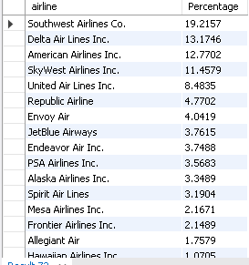

3.#show top 5 cities where the most flights happen to for southwest airlines

select origin_city, count(origin_city) AS originCityCount from flightdata where airline = "Southwest Airlines Co."

group by origin_city order by originCityCount desc LIMIT 5;

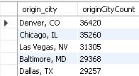

select dest_city, count(dest_city) AS destCityCount from flightdata where airline = "Southwest Airlines Co."

group by dest_city order by destCityCount desc LIMIT 5;

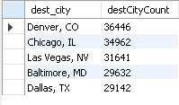

4. percentage of denver and chicago

#show denver and chicago as percentage of flights both origin and destination

select origin_city, (count(origin_city)/(select count(origin_city) from flightdata where airline = "Southwest Airlines Co."))*100 AS originCityPerc from flightdata where airline = "Southwest Airlines Co."

group by origin_city order by originCityPerc desc LIMIT 5;

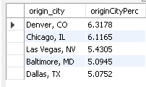

select dest_city, (count(dest_city)/(select count(dest_city) from flightdata where airline = "Southwest Airlines Co."))*100 AS destCityPerc from flightdata where airline = "Southwest Airlines Co."

group by dest_city order by destCityPerc desc LIMIT 5;

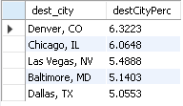

5. #Show number of flights per year by SAC

select substring(fl_date,1,4) as flYear, count(fl_date) as Cnt from flightdata where airline = "Southwest Airlines Co." group by substring(fl_date,1,4);

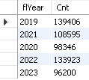

6. show tally per case of cancellation

select airline,

sum(case when dep_delay> 0 THEN 1 ELSE 0 END) AS DEP_DELAY,

sum(case when ARR_DELAY> 0 THEN 1 ELSE 0 END) AS ARR_DELAY,

sum(case when DELAY_DUE_CARRIER> 0 THEN 1 ELSE 0 END) AS DELAY_DUE_CARRIER,

sum(case when DELAY_DUE_WEATHER> 0 THEN 1 ELSE 0 END) AS DELAY_DUE_WEATHER,

sum(case when DELAY_DUE_NAS> 0 THEN 1 ELSE 0 END)AS DELAY_DUE_NAS,

sum(case when delay_due_security> 0 THEN 1 ELSE 0 END) AS delay_due_security,

sum(case when delay_due_late_aircraft> 0 THEN 1 ELSE 0 END) AS delay_due_late_aircraft,

sum(case when CANCELLED> 0 THEN 1 ELSE 0 END) AS CANCELLED

FROM FLIGHTDATA WHERE AIRLINE = "Southwest Airlines Co.";

